**CONCEPT PAPER**

**COVID-19 FORCED BUSINESS TRANSFORMATION: A PHILIPPINES BUSINESS INDUSTRY PIVOTS IN STATE OF FURTUITOUS EVENTS**

**WEBINAR OF YES ORG 2021**

**ACCOMPLISHMENT REPORT**

**DOCUMENTATION**



**The event was started by the emcee ms. Nikki ronquillo from BSENT 2-1 and it was followed by the welcoming of the students form different branches of PUP and partner school organization.**

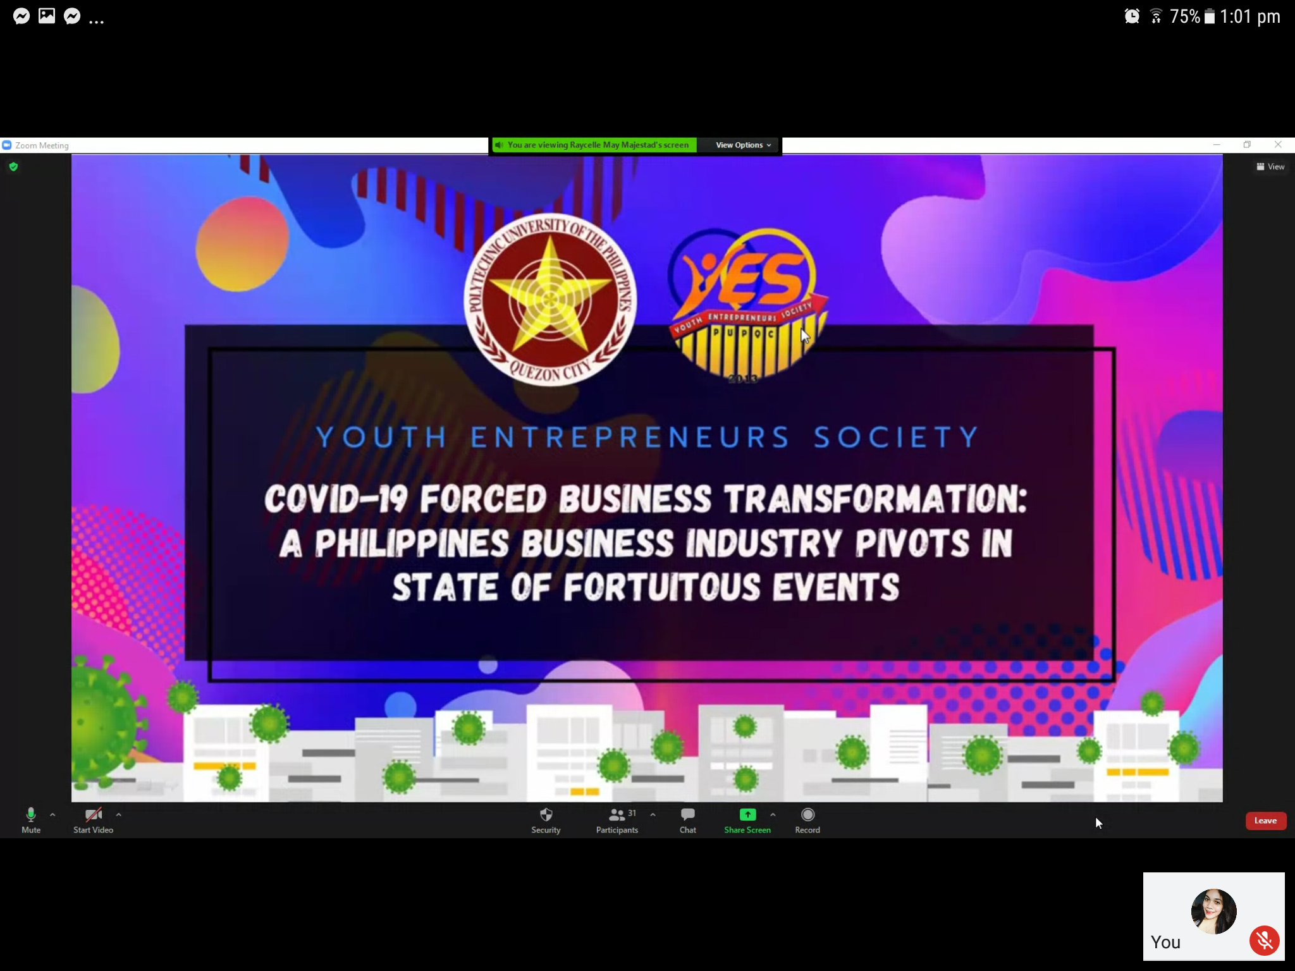

**The opening ceremony was started by the president of YES ORG mr johnric delos reyes**

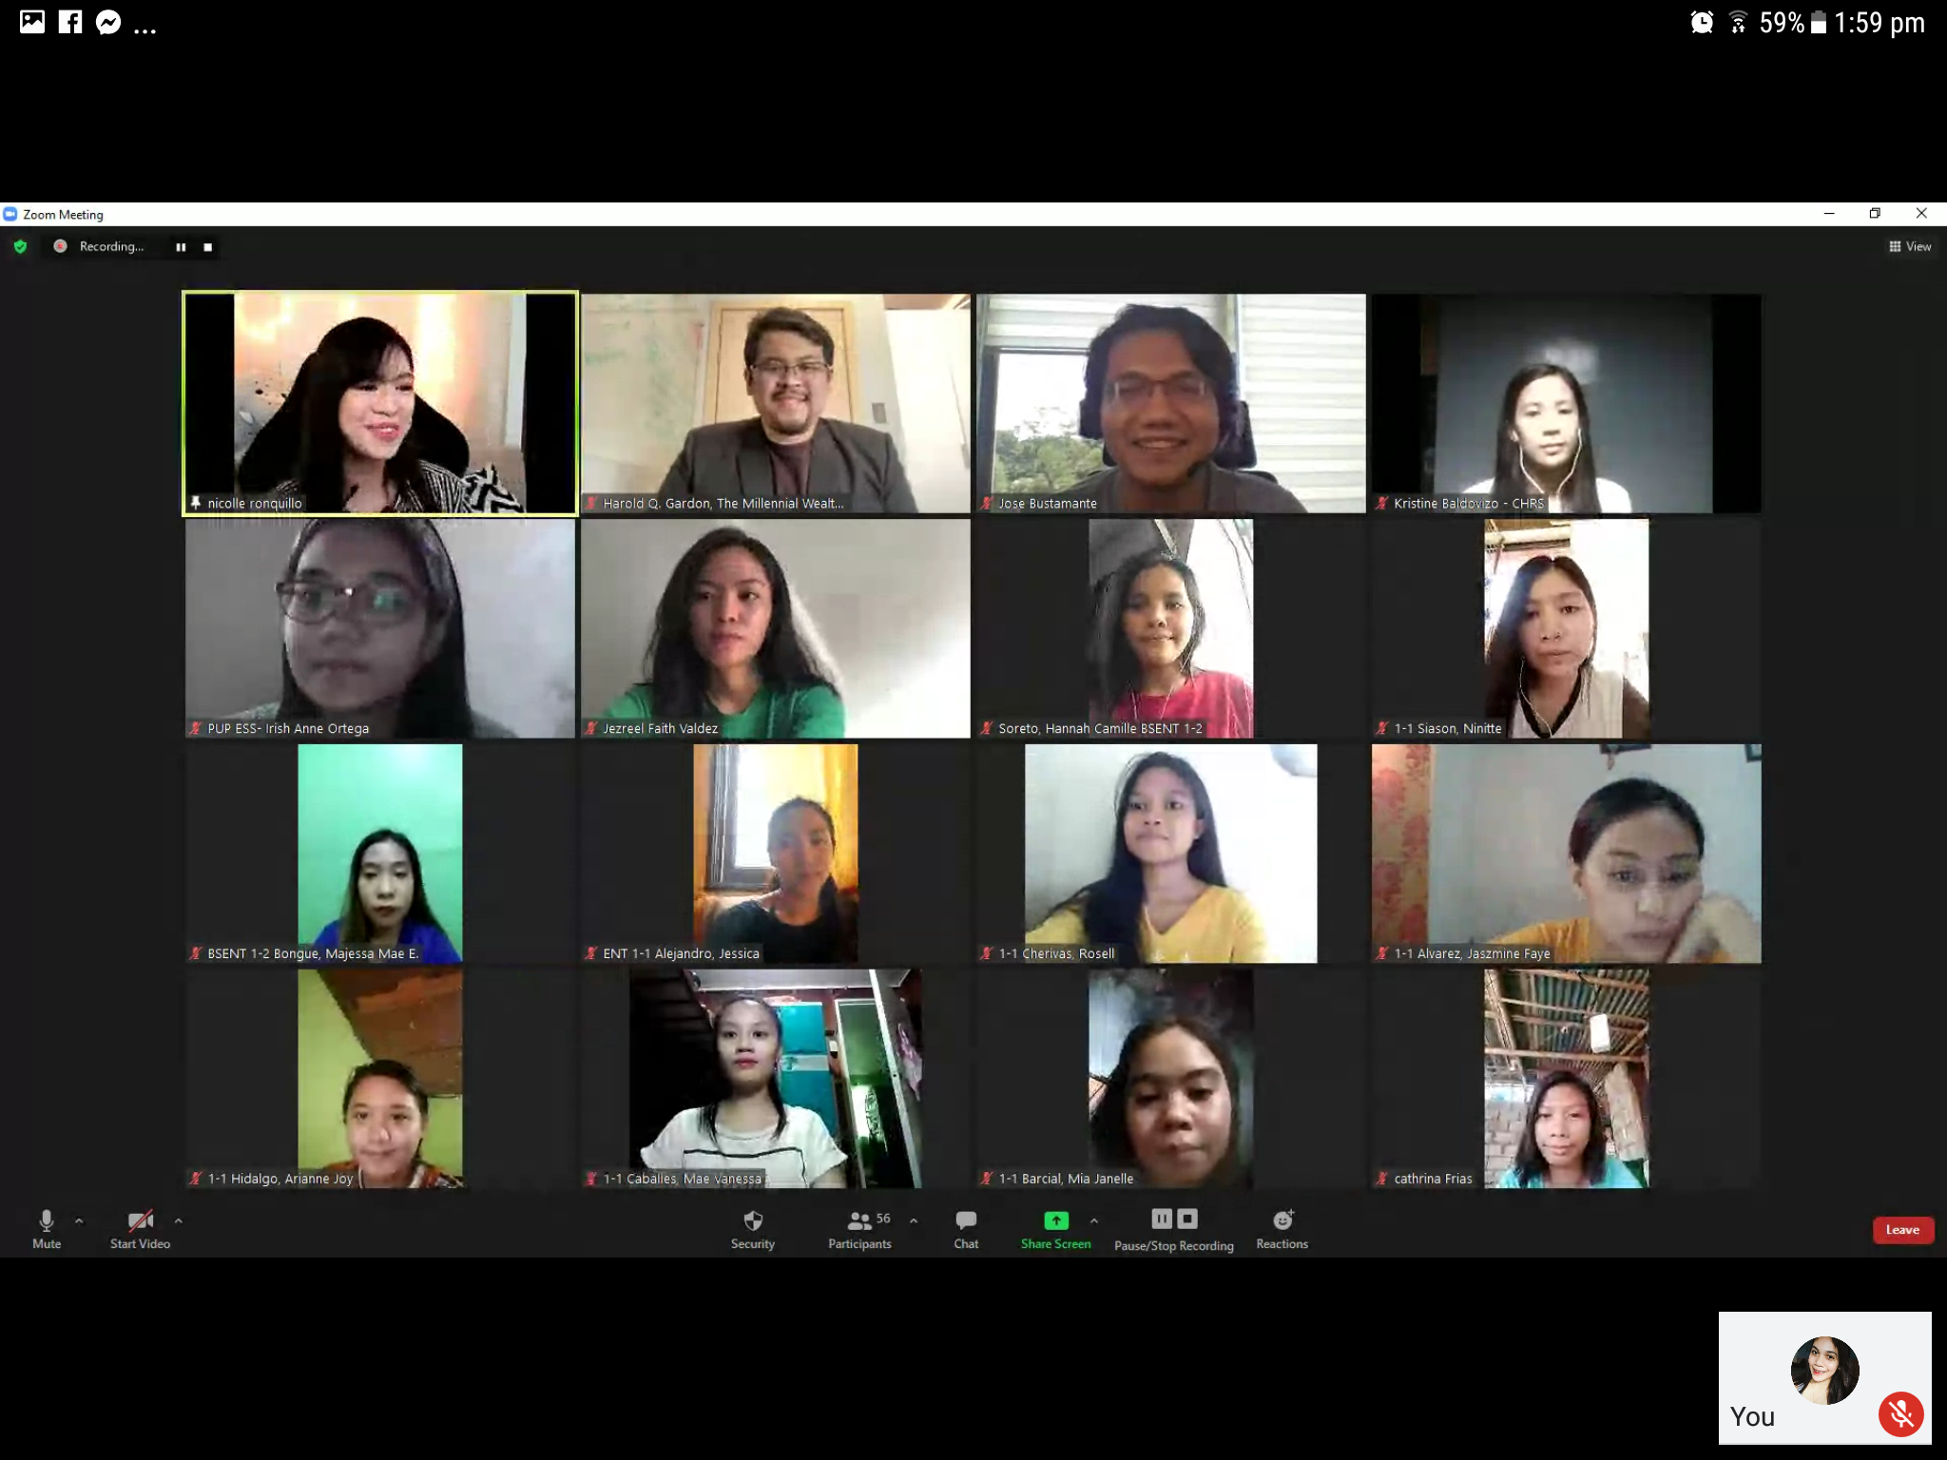

**The opening of the event was started by the opening prayer which was sung by ms jackielyn san juan of BSENT 3-1 and was followed by the Philippines national anthem**

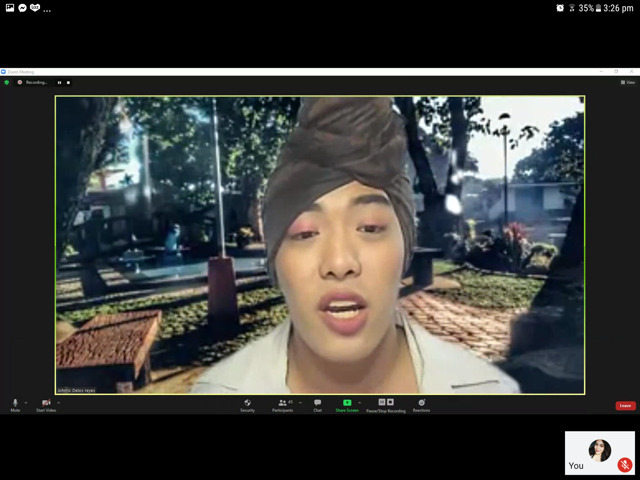

**And it was followed by the welcoming and opening message from the president of YES organization mr johnric delos reyes.**



**And was followed by the warm message from the YES advisor Dr. prof. Rodrigo Dolorosa**

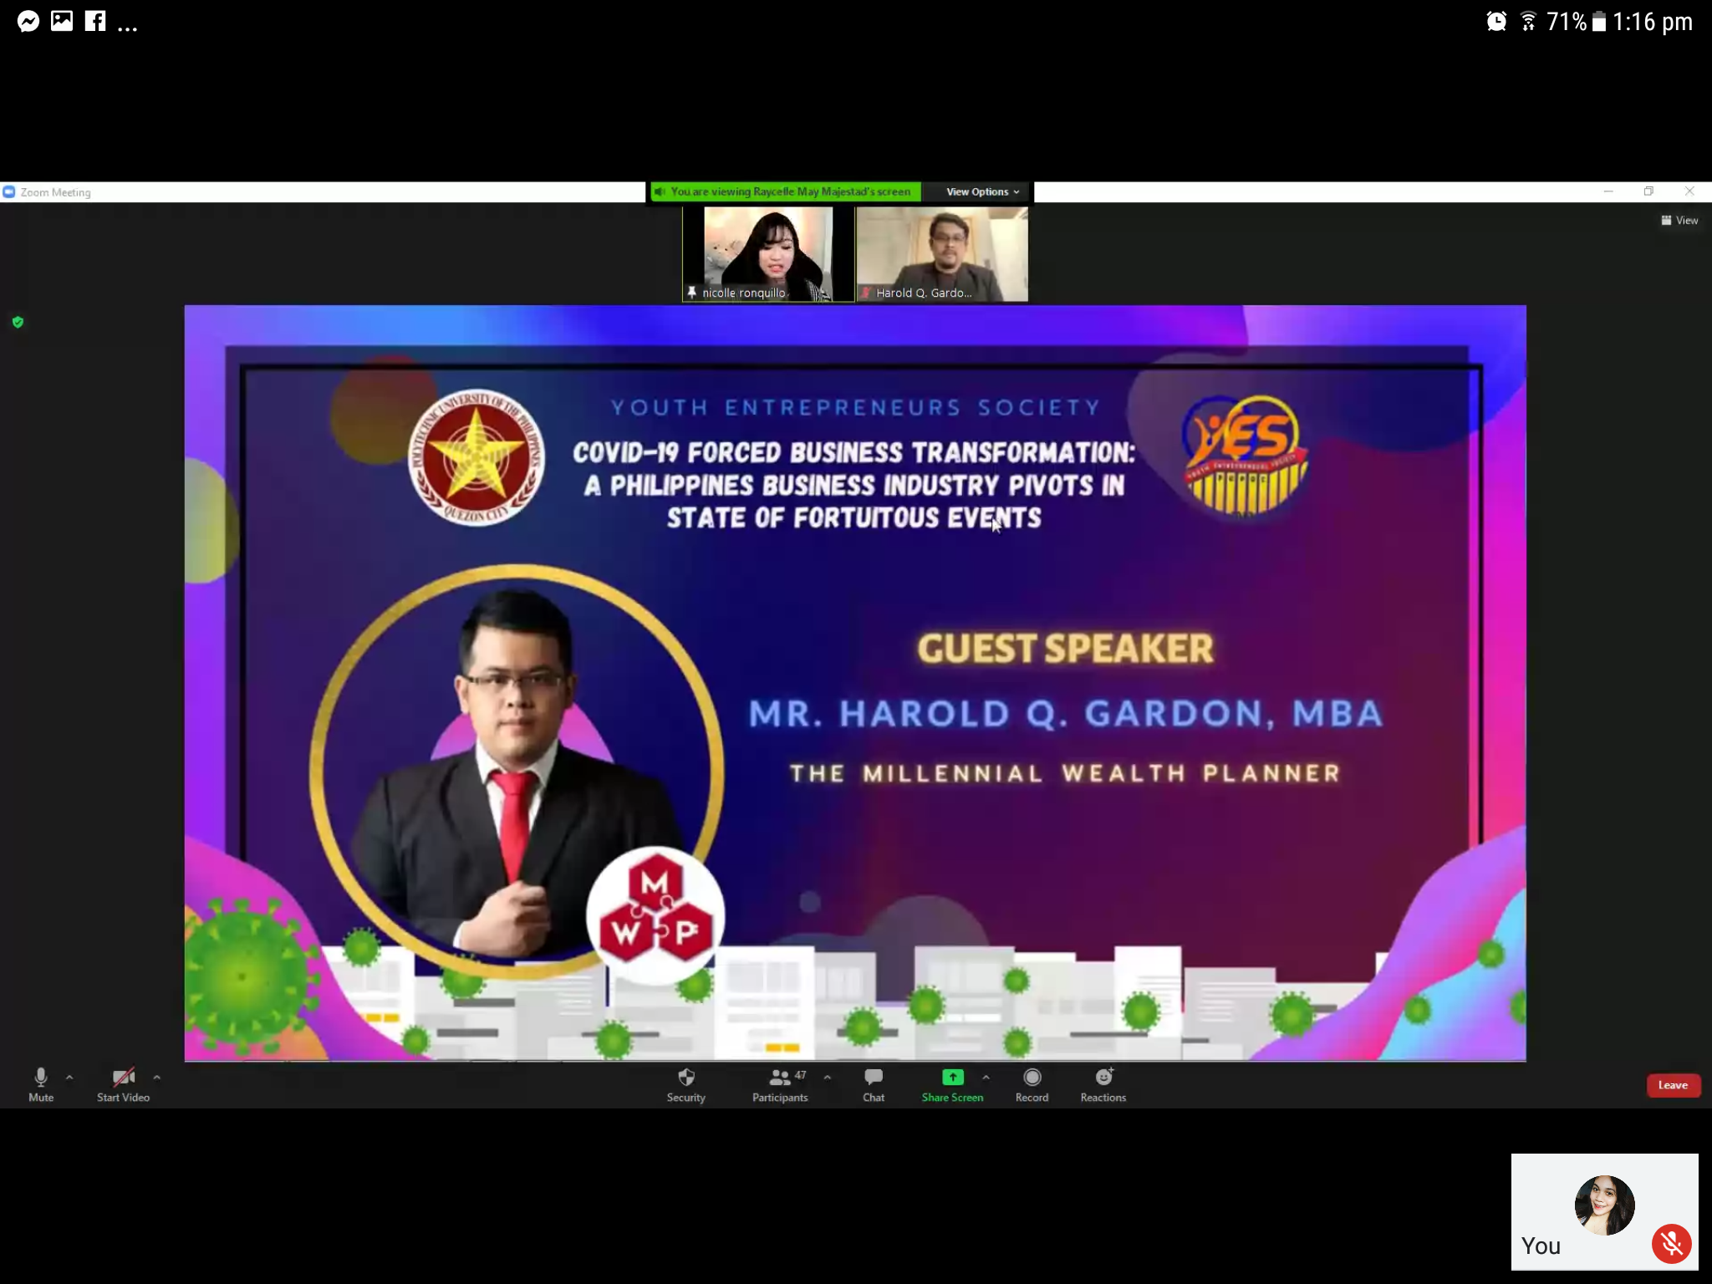

**And was then followed by the main event by introducing the first speaker Mr. Harold Gardon**

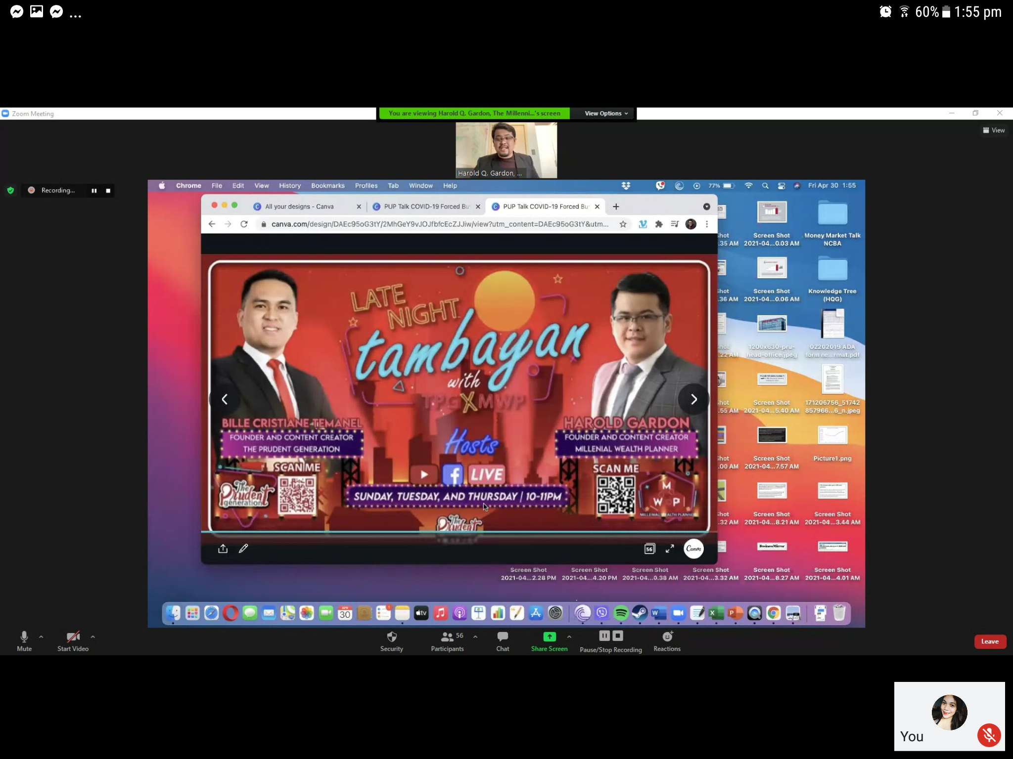

**After his 30 mins talk it was followed by the awarding of certificate**

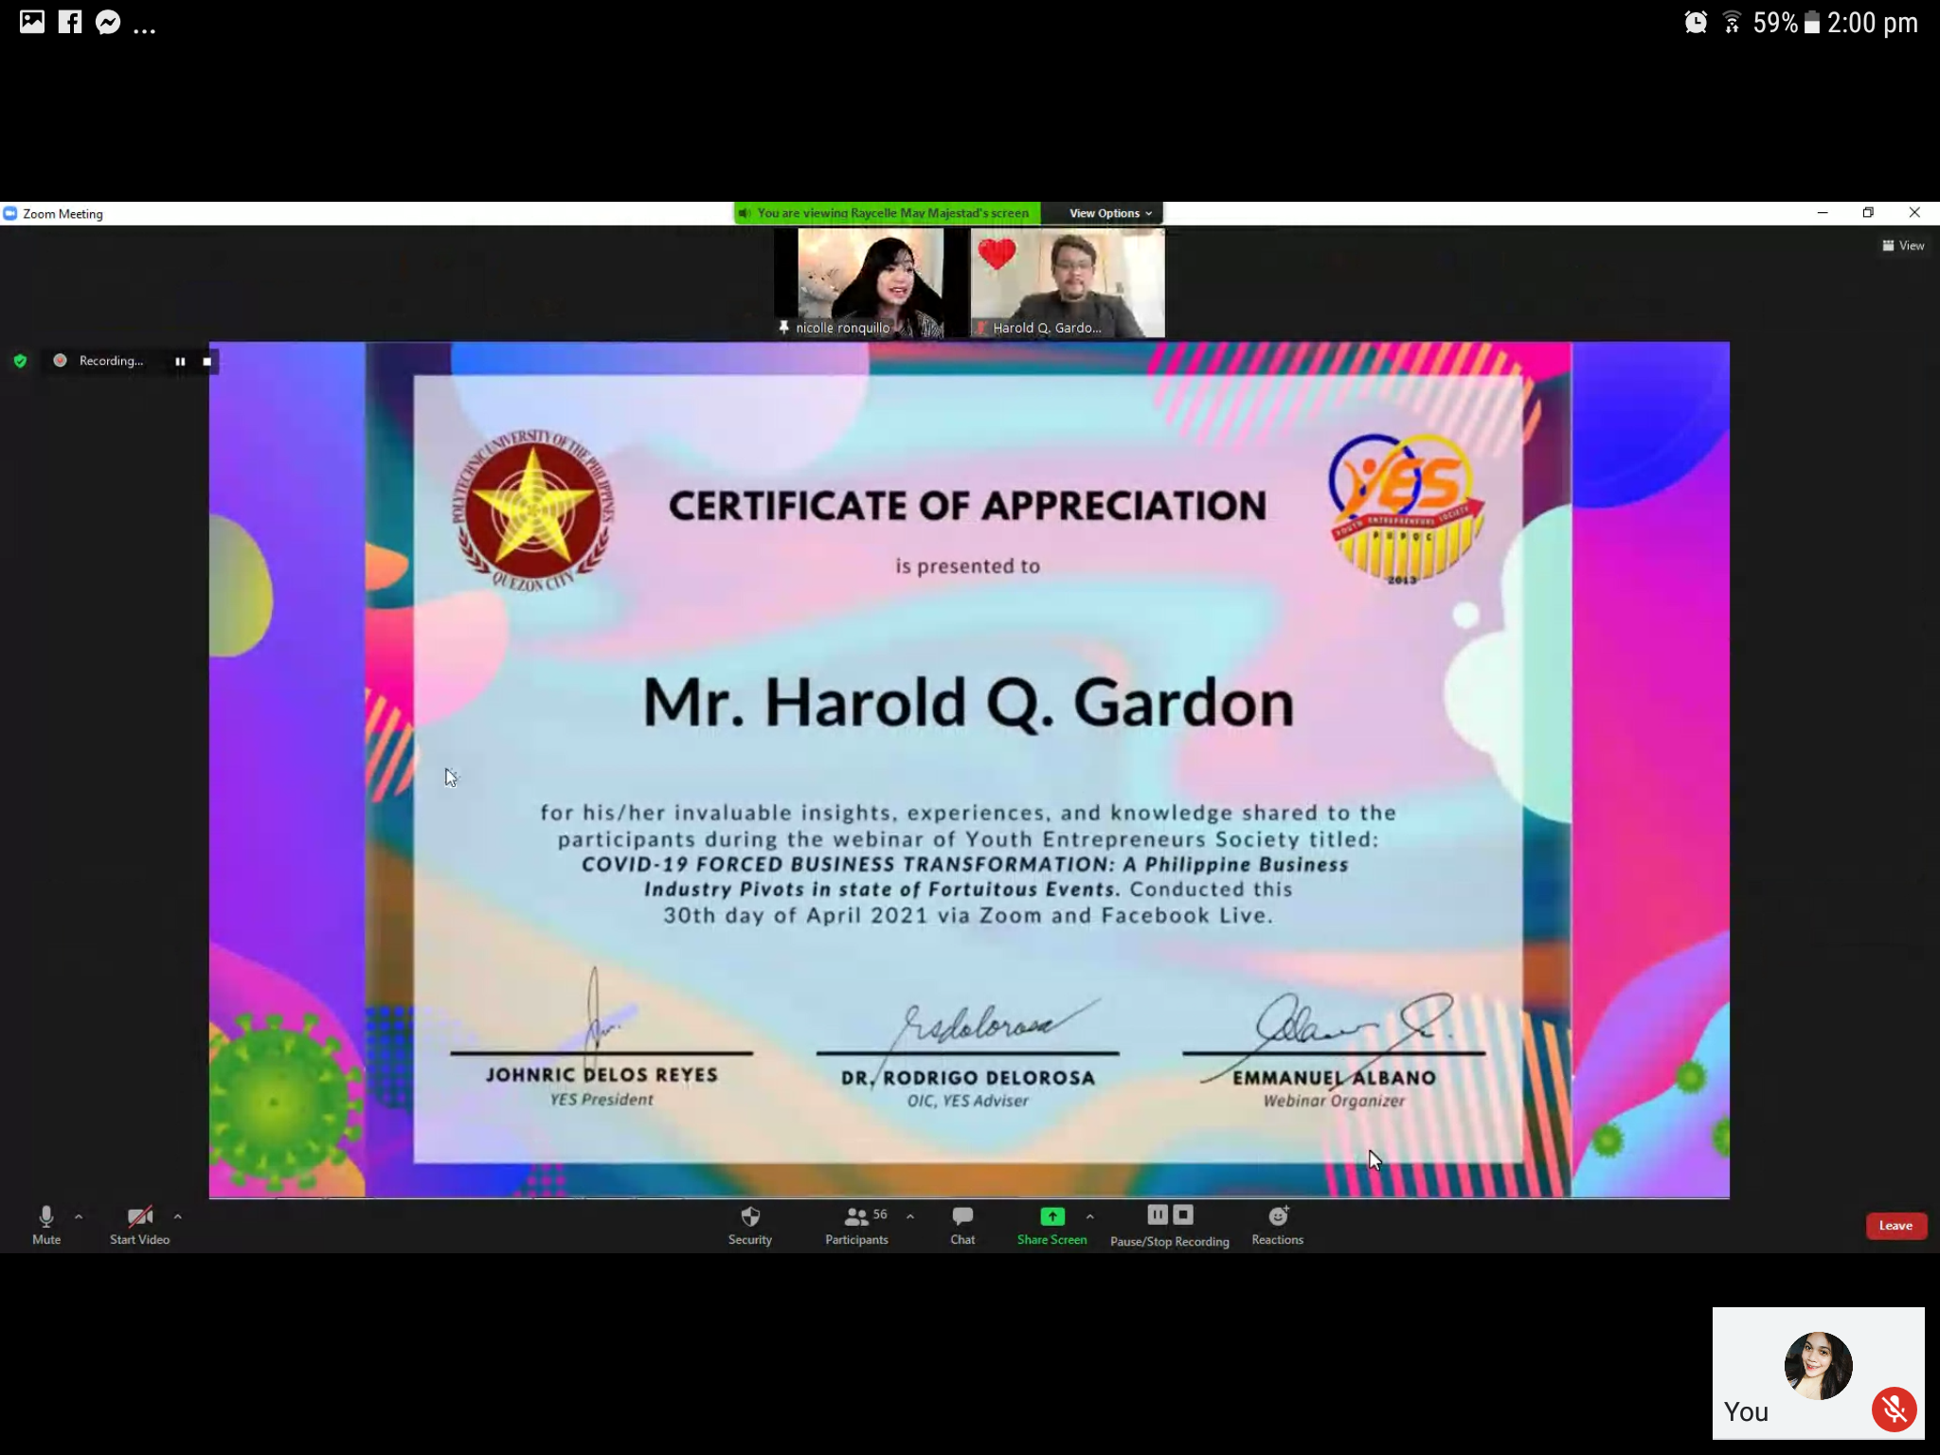

**And a photo opportunity was given after the awards**



**And was then followed by introducing the second speaker mr calel bustamante**

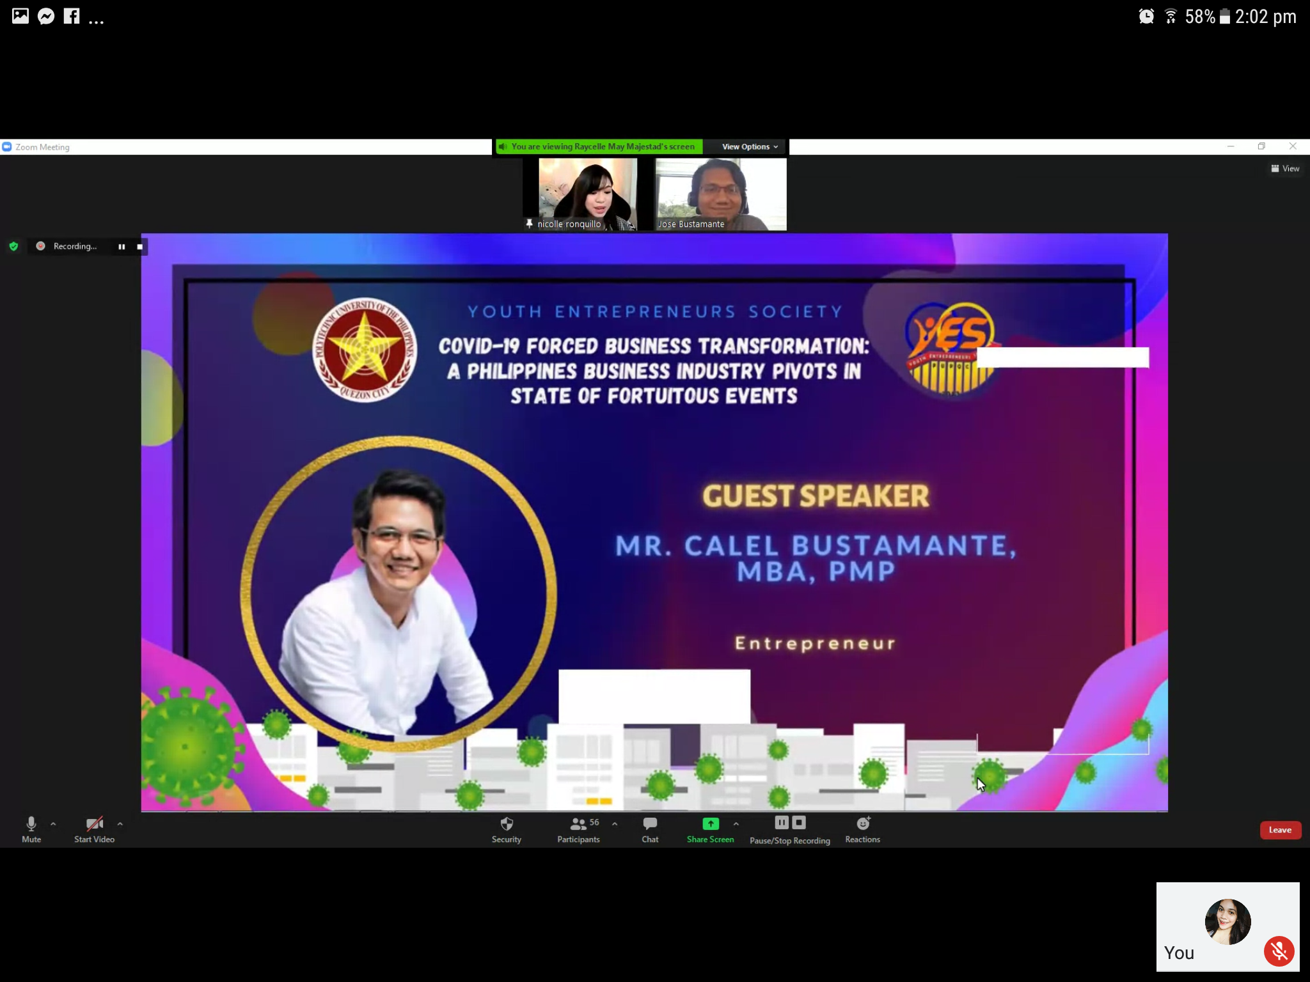

**And was then followed by his 30 mins talk**

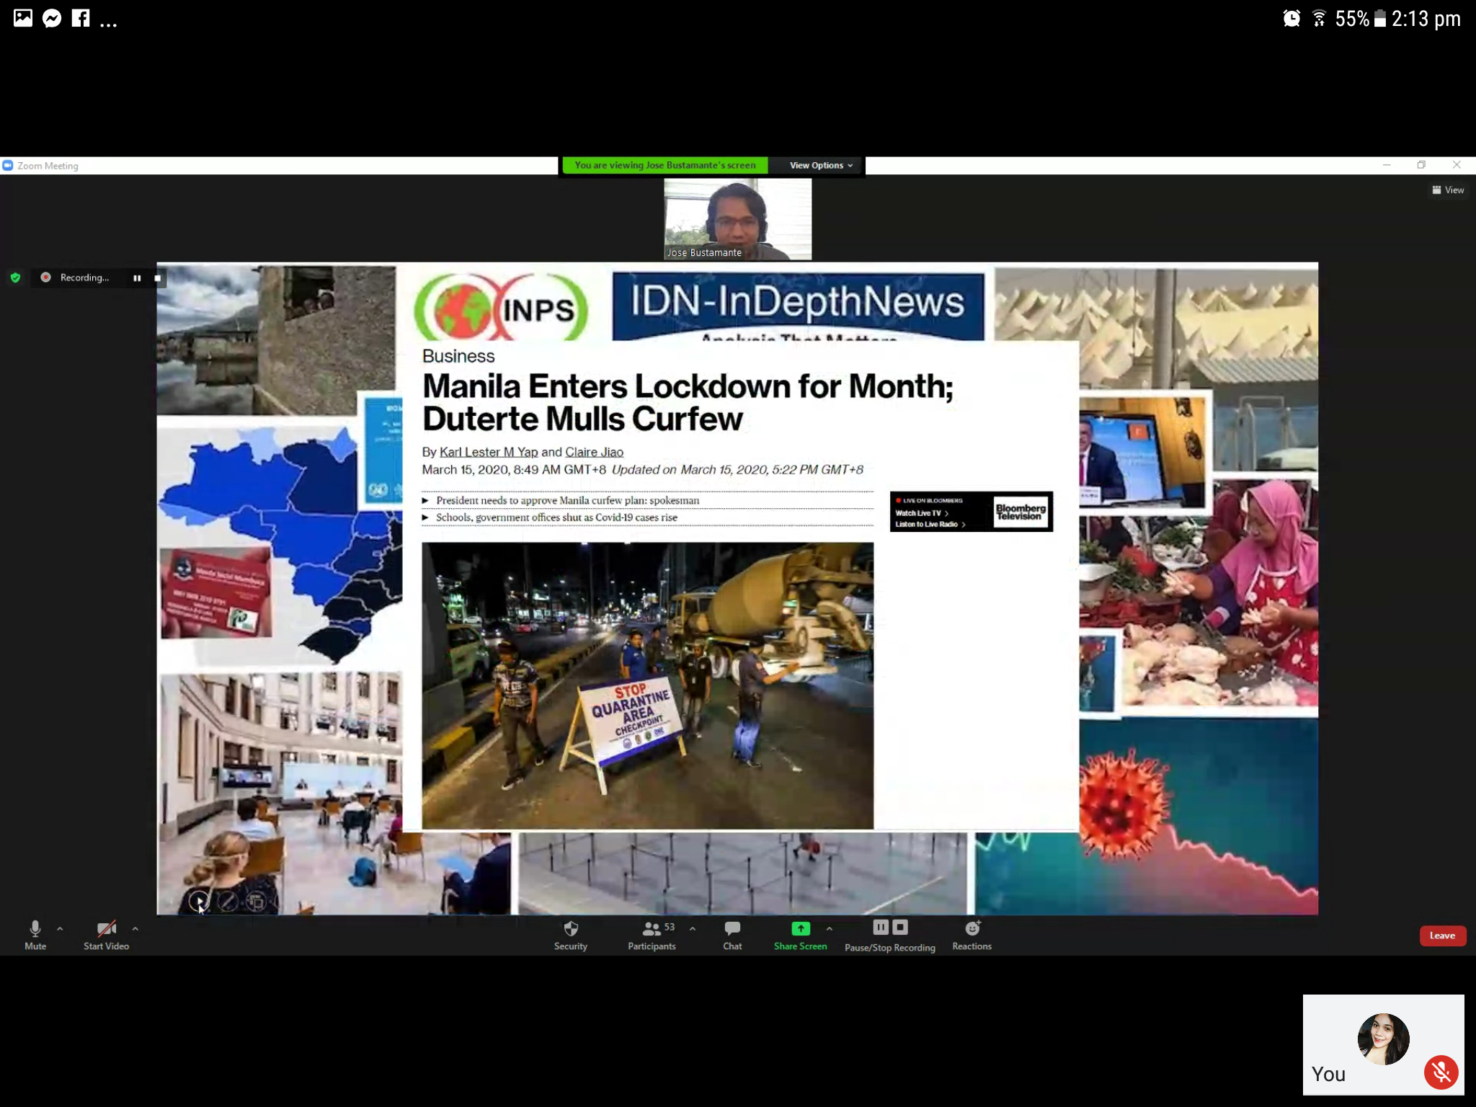

**And it was followed by the awarding of certificate and**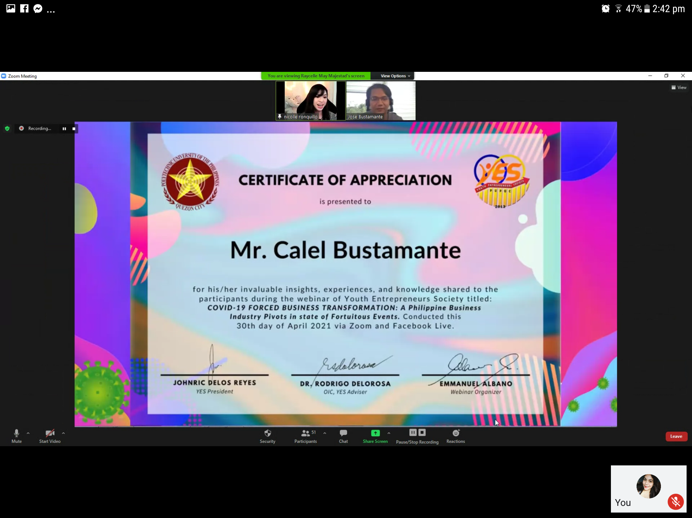

**And was followed by a photo opportunity**

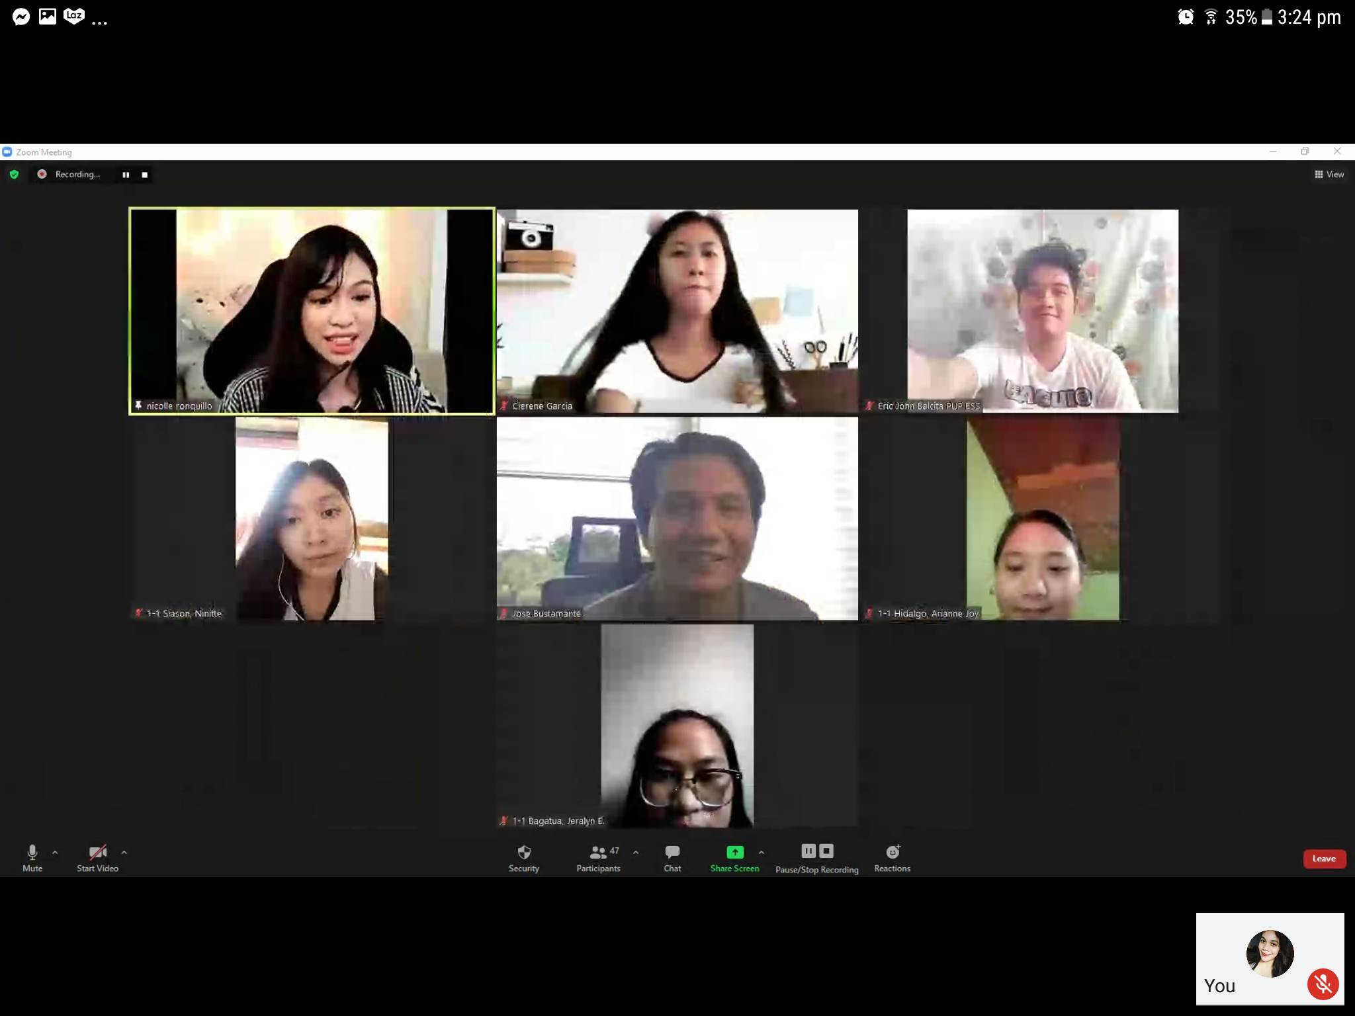

**That was followed by the introduction of the last speaker ms. Jane tiongco-aguirre**

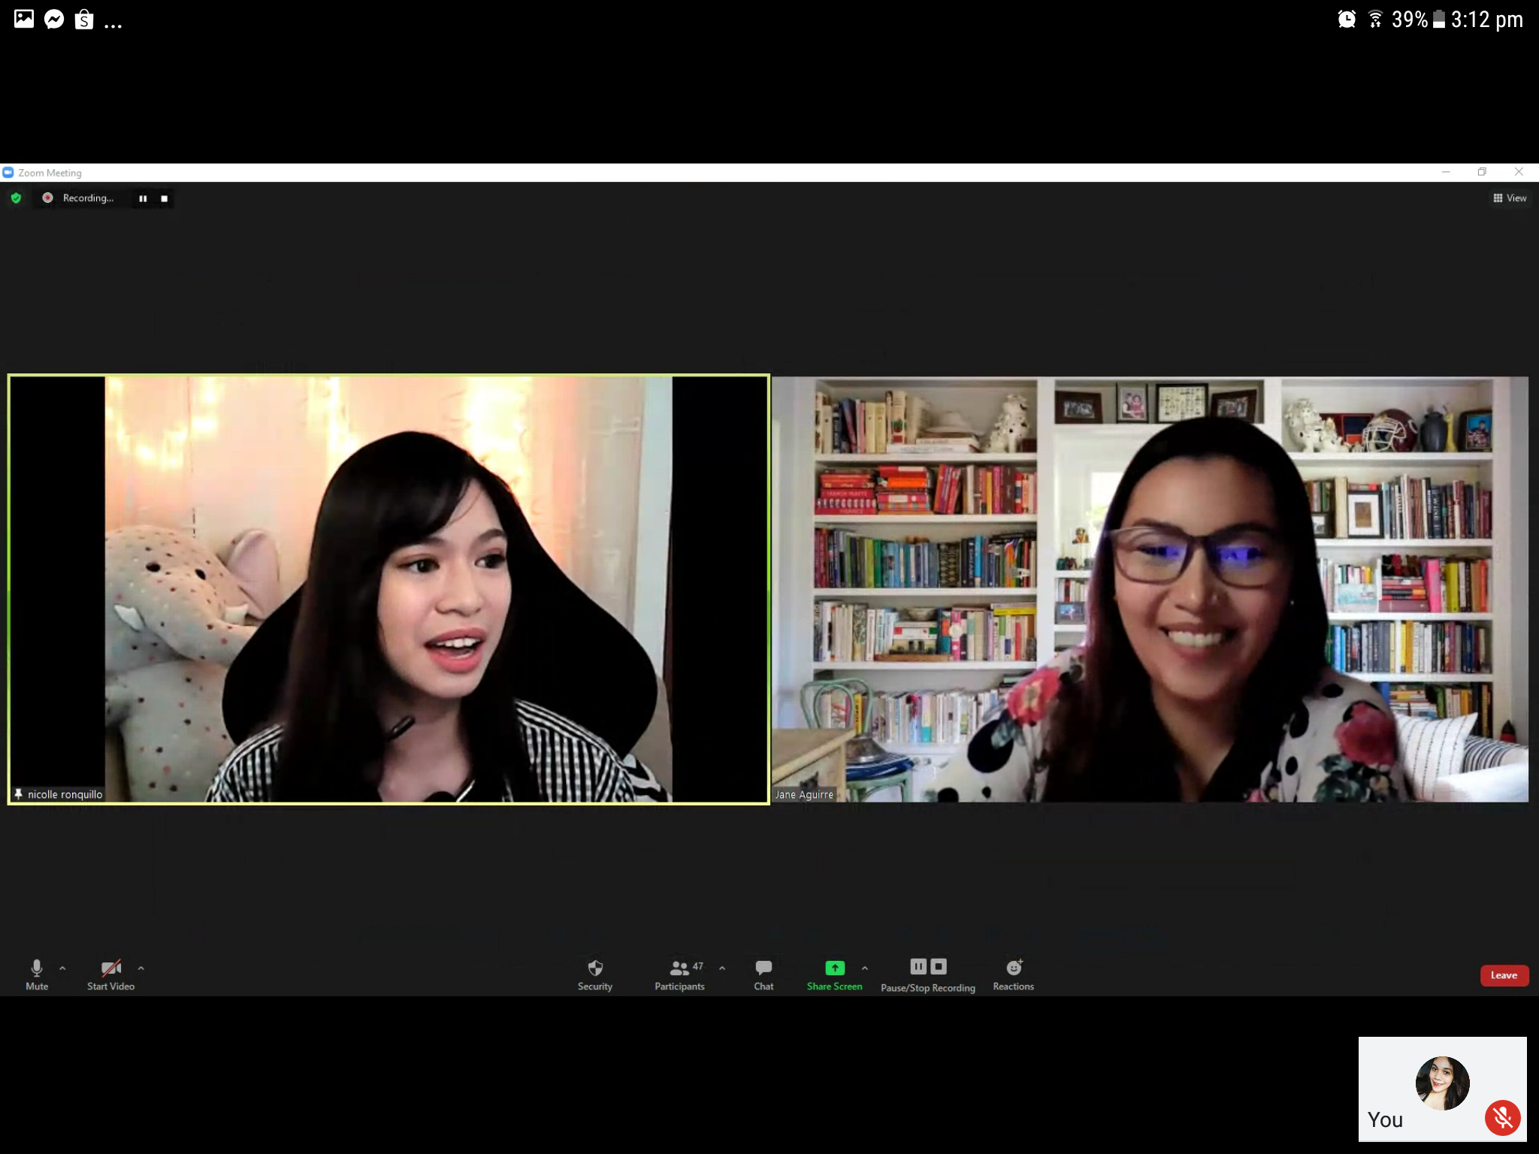

**Ms jane aguirre is a marketing director of grolier Philippines**

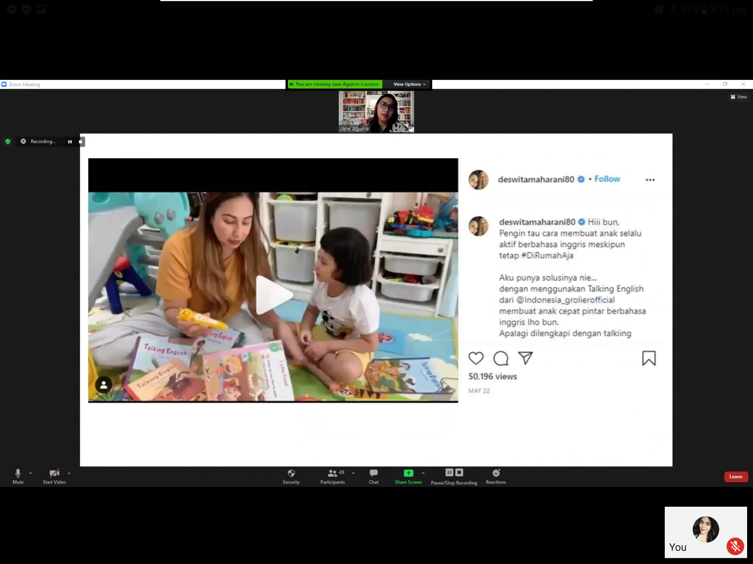

**After her 30 mins. Talk it was the followed by the awarding of certificate**

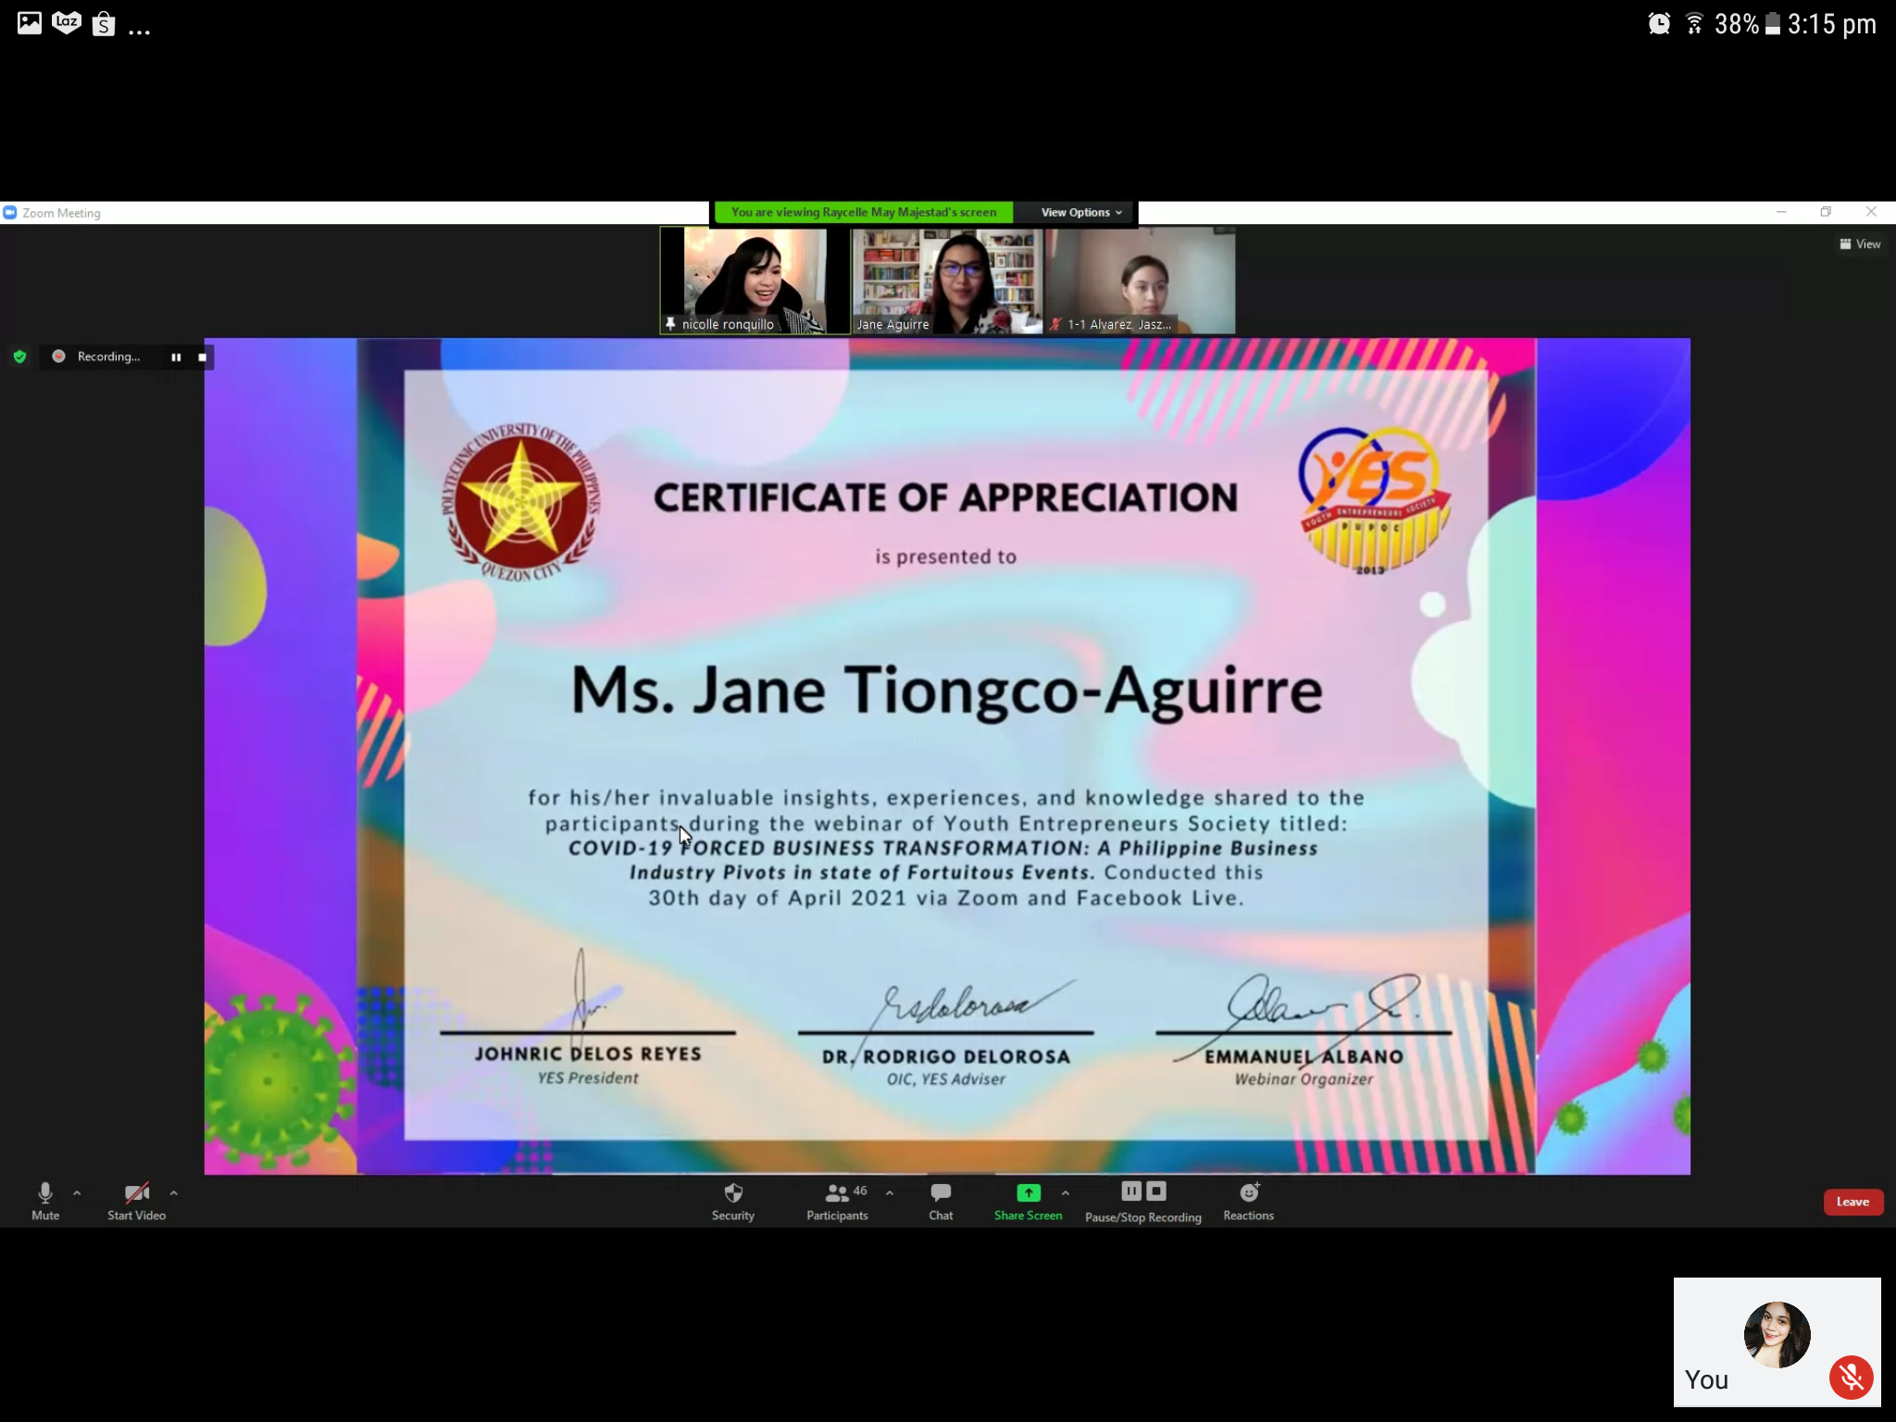

**After the awards it was then followed by the photo opportunity**

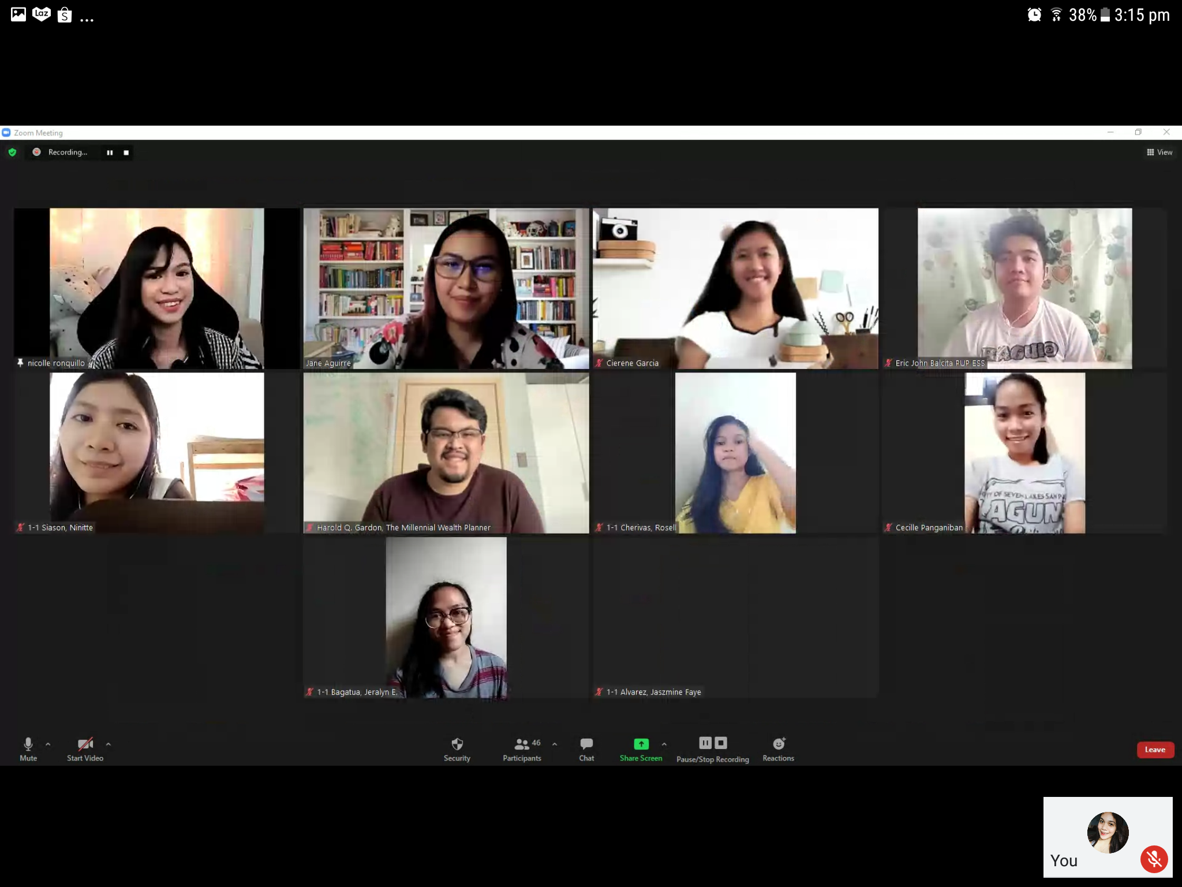

**Before closing the event there was a giveaway that was sponsored by one of the respectable speaker mr. Calel bustamante a lyda.com account**



**And was followed by the [presentation of the partner school organization from different PUP branches and other schools**

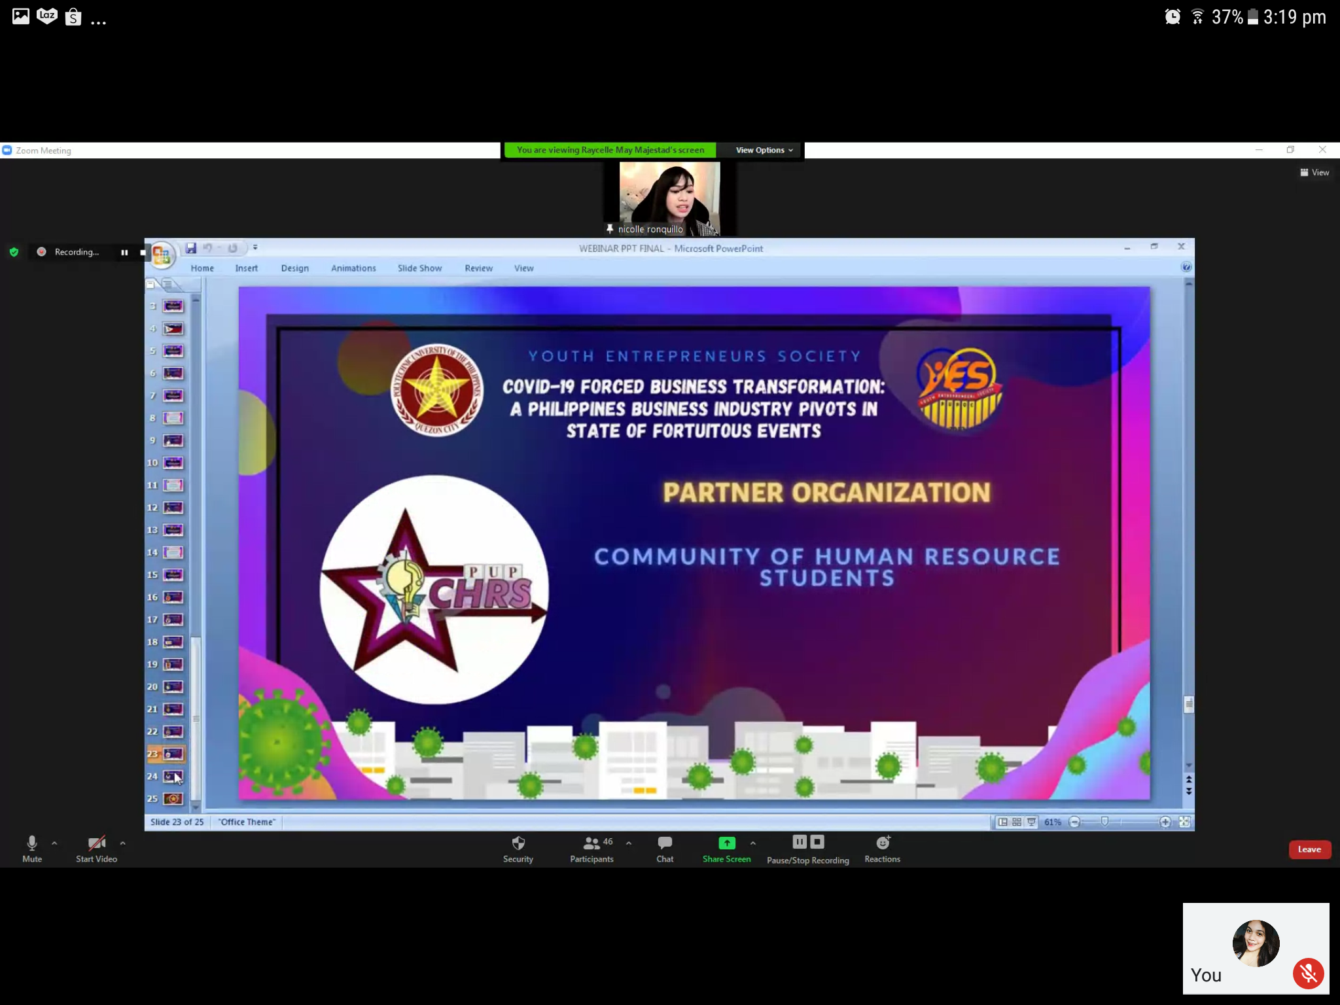

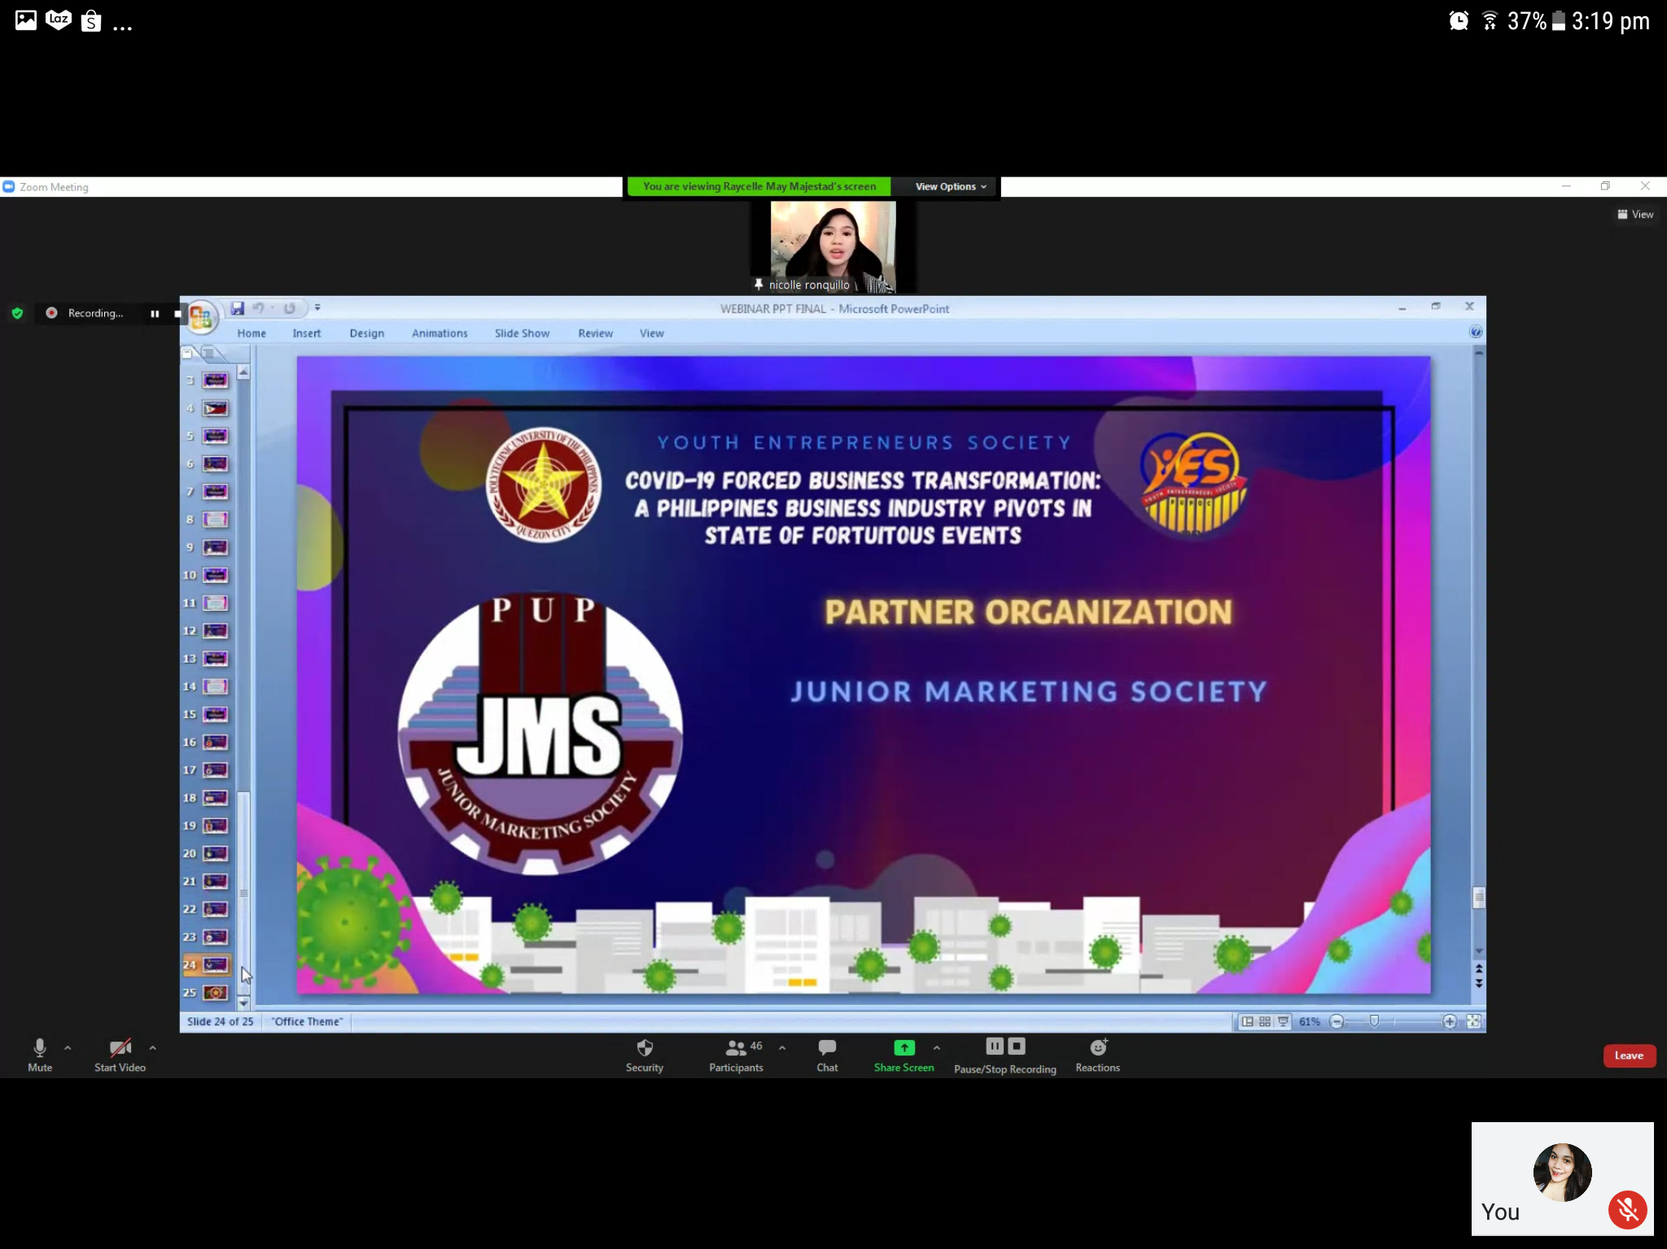

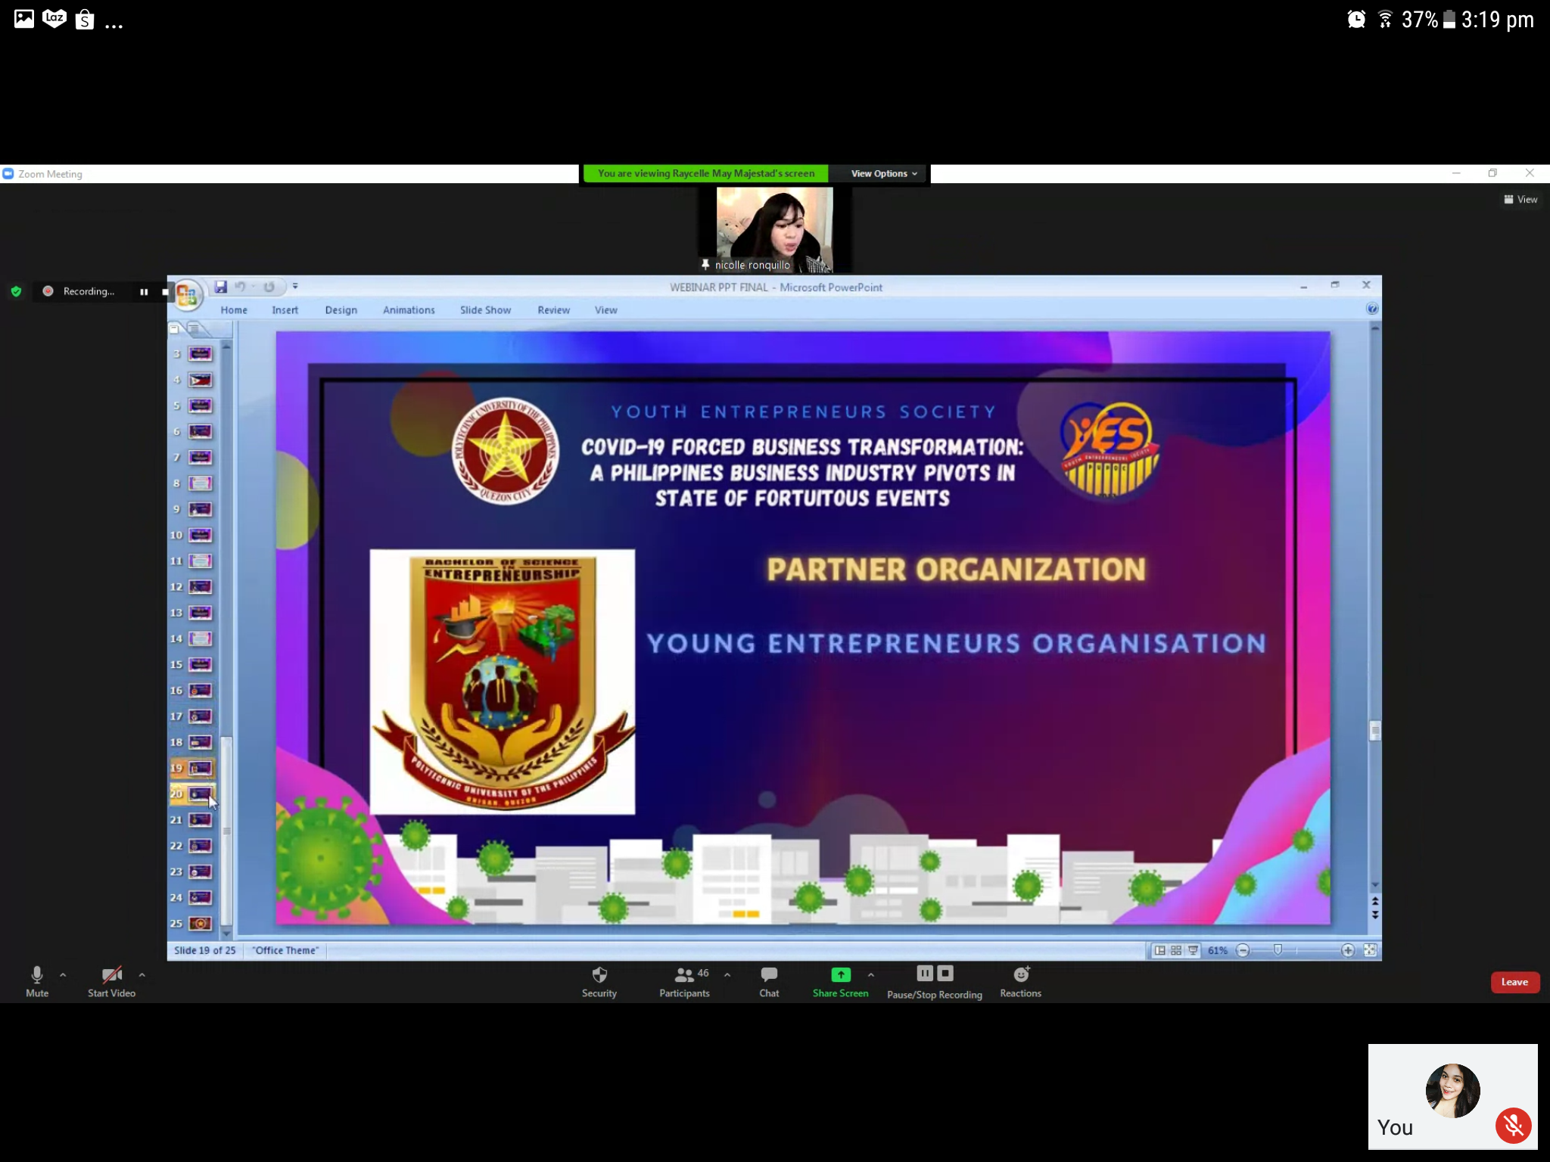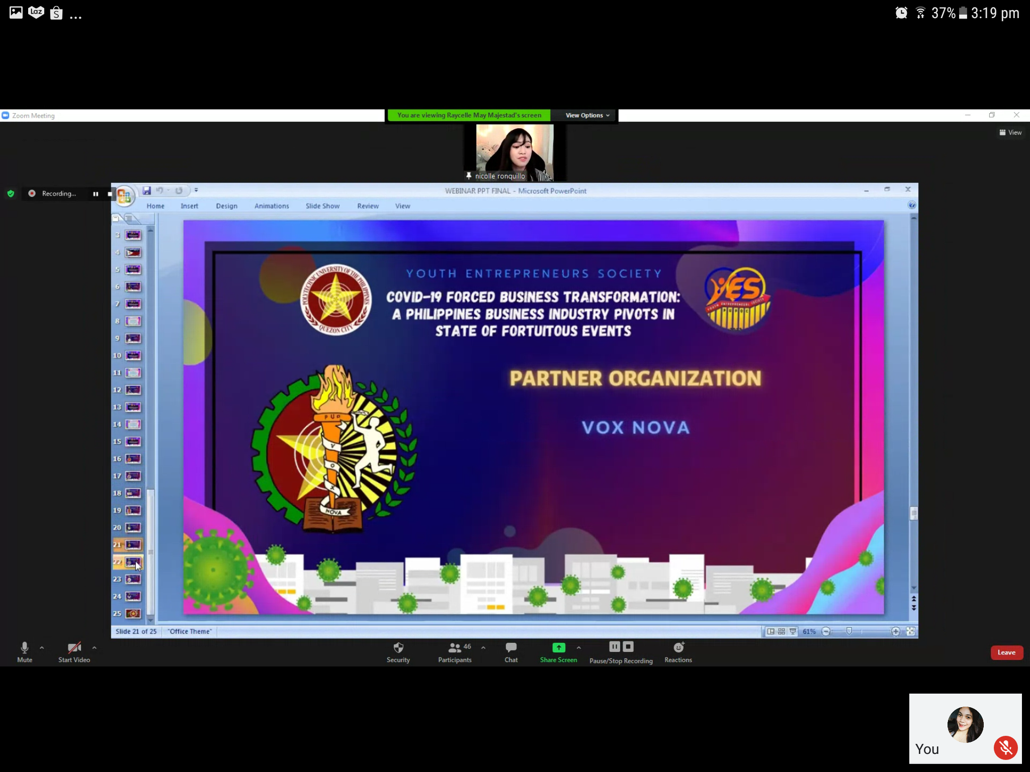

**And it was then followed by the closing speech and a thank you message from the YES president Mr. Johnric Delos Reyes.**





**And finally the closing ceremony was signaled by singing the Polytechnic University of the Philippines hymn**

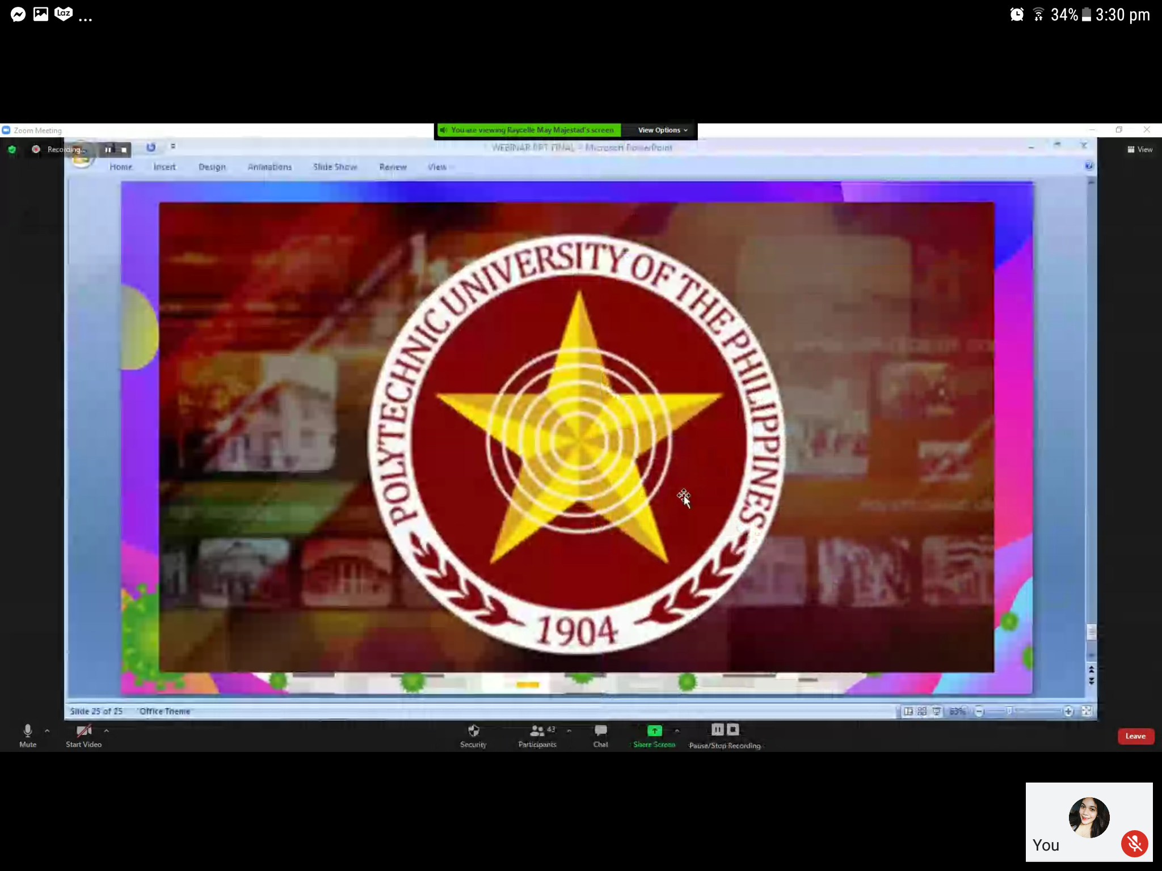



**And finally the closing of the event.**